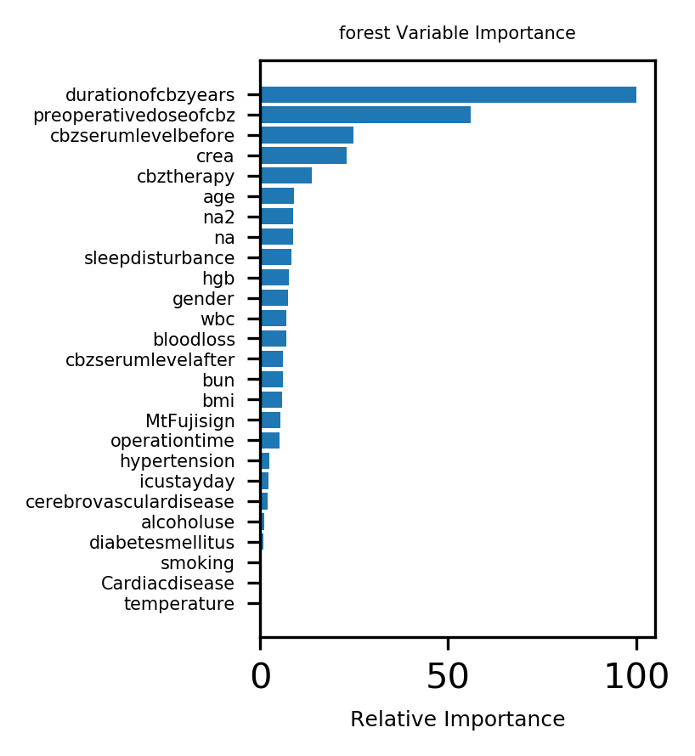

Supplementary Figure 1 Forest algorithm feature picture

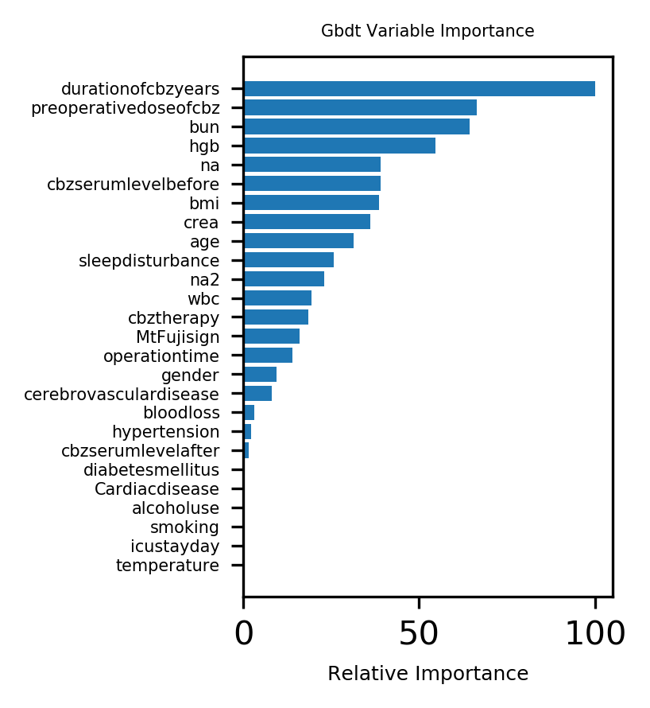

Supplementary Figure 2 Gbdt algorithm feature picture

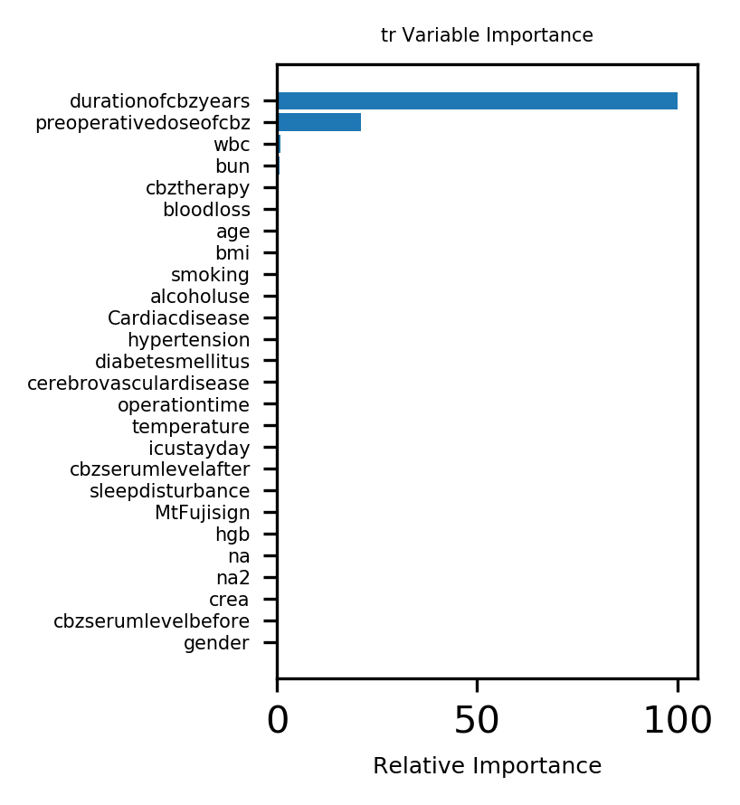

Supplementary Figure 3 Tree algorithm feature picture